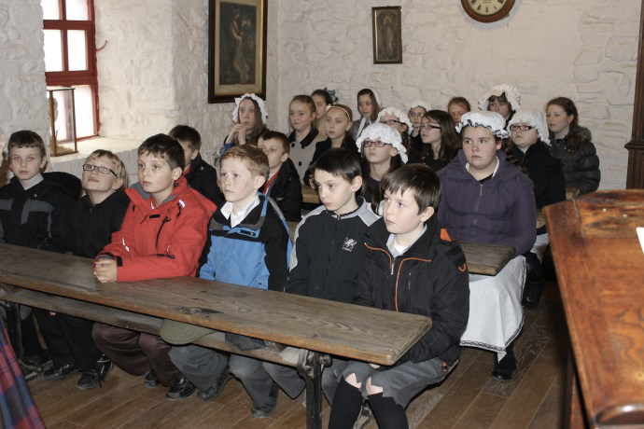

Workshop: Victorian Schoolroom
Key Stage: KS1 & KS2
Learning Objectives:: How was a Victorian school different to school today?
What was the life like for children in Victorian times?
Curriculum Links: KS1 Historical Enquiry - 4a
Breadth of Study – 6b
KS2 Chronological understanding - 1a
Knowledge and understanding of events, people and changes - 4a &b
Local history study - 7.
British history - 8a
Victorian Britain - 11a
Workshop Description: Dress in Victorian costume and experience a ‘chalk and talk’ Victorian classroom lesson with our school Dame, Miss Wright. Costumes can be provided for pupils to help them get into character if they wish or you are very welcome to bring your class dressed up for the experience! The session takes place in our Victorian-style classroom with old fashioned desks, slates to write on, a blackboard, an abacus and a piano. Lessons will include, reading, times tables, practicing handwriting and general Victorian knowledge. Some typical Victorian classroom punishments are also demonstrated during the session. (willing victims only!)

