Site Information
The Camp Mill Site
The Dean Heritage Centre is based in five acres of scenic woodland and aims to protect, preserve and promote the unique history and heritage of the Forest of Dean.
It tells the story of the Forest of Dean and its people, spanning 10,000 years of history, from the Ice Age to the present day.
Onsite there is a wide-ranging collection of around 20,000 historic objects, covering subjects such as archaeology, industry (coal mining and iron making), transport, childhood history, music and costume. These artefacts are based in five modern galleries housed in a former Mill building, which has its own modern running waterwheel.

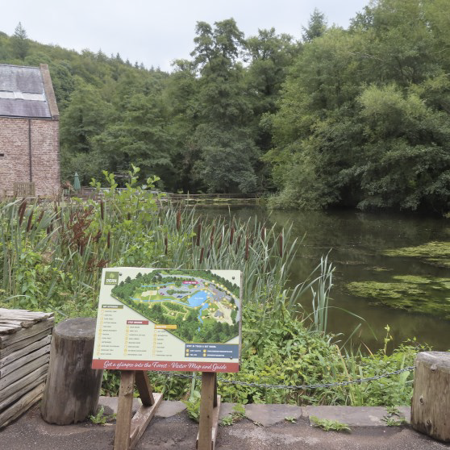

The Museum
Gallery 1: Pre-historic and Early History
Gallery 1 investigates the fascinating geology and landscape of the Forest of Dean. Displays reveal the fossilised remains of the plants and animals that once inhabited the area, as well as the pre-historic tools of the Forest's first farmers. Early Roman occupation and the iron industry are also explored.
Gallery 2: Medieval to 18th Century History
Gallery 2 explores the history of the Dean as a Royal Medieval hunting forest.
Forest Laws were introduced to protect the deer and the boar hunted by Kings, and the woodland in which they grazed.
The rules were administered by special courts and officials known as ‘Verderers’._ _
This gallery also explores the part played by the Forest of Dean in the English Civil war and tells how Admiral Nelson saved the Forest from destruction.

Gallery 3: Industry & Society
Gallery 3 examines the Forest of Dean's industrial legacy from Victorian times onwards. It examines the fishing industries generated by the Rivers Severn and Wye to the many cottage crafts such as cobbling, carpentry and blacksmithing.
A significant part of the gallery is dedicated to the Dean's coal mining past, from stories of mining disasters and rescues to the everyday tools and objects that were part of the miner's life.

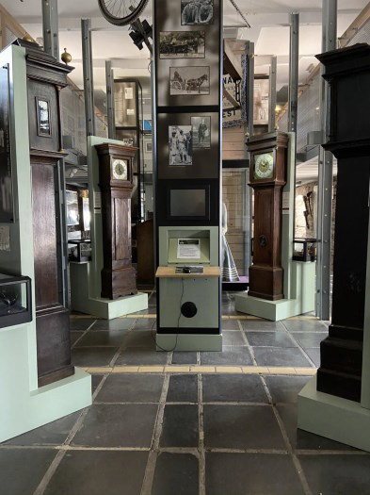

Contemporary History: 2 WW to the present day
Gallery 4 is also known as '' Gallery 41,'' and is the community gallery. (41 parishes make up the Forest of Dean district.)
As well as a display about the Forest during the Second World War, the gallery features a changing programme of exhibitions by local individuals, clubs, community groups and schools.
Power & Transport from 1800s: Gallery 5
Gallery 5 focuses on the advent of steam power and transport from the 1800s. The gallery features a working Beam Engine, which was made at Hewlett's iron foundry at Camp Mill, the site of the present Museum.
It also features other working models and interactive displays demonstrating the use of steam power.
